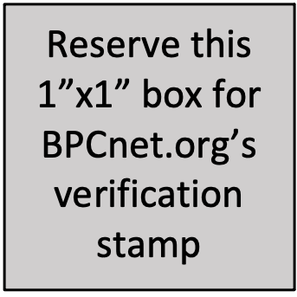
Departmental BPC Plan
[Department Name]
[Institution Name]

Effective dates of Plan: Leave full line for BPCnet staff to add your dates.
Your Departmental BPC Plan’s effective start date will be the date that it is verified, and your effective end date will be two years from that verification date.
Contact: [The individual(s) responsible for overseeing the Departmental BPC Plan.]
When you complete this section, you should have met these expectations from BPCnet.org:
- Includes the institution’s name and the name of the department.
- Reserves one line for BPCnet staff to insert a start and end date for the Departmental BPC Plan OR you have set your own effective dates if not submitting for verification
- Includes the name, role, and contact information for the individual(s) responsible for overseeing the Departmental BPC Plan.

Context
When you complete this section, you should have met these expectations from BPCnet.org:
- Includes relevant, currently available data that is related to the goals.
- Includes data that does not violate privacy or make people feel singled out.

Goals, Activities, and Measurement
G1: [Insert goal 1]
A1: [Insert activity for goal 1]
M1: [Insert measurement for activity 1]
If there are multiple activities for one goal, they can be identified in the Plan as:
G2: [Insert goal 2]
A2a: [Insert activity for goal 2]
A2b: [Insert activity for goal 2]
A2c: [Insert activity for goal 2]
M2: [Insert measurement for goal 2 activities]
Repeat as needed.
Consider making a copy of this spreadsheet (make a copy) to facilitate collecting a list of existing activities.
When you complete this section, you should have met these expectations from BPCnet.org:
- The Plan identifies the BPC goals the department is focusing on.
- All goals are specific, measurable, attainable, relevant, and time-bound (SMART).
- All goals will focus on BPC as defined by NSF CISE (see https://www.nsf.gov/cise/bpc/) but may also include additional groups for BPC.
- All goals have an identifier for reference elsewhere in the document. (e.g., G1, G2)
- Each activity has an identifier for easy reference in a Project BPC Plan (e.g., A1, A2).
- Each activity identifies which goal(s) it is intended to help achieve using the identifiers set in the goals section (e.g., G1, G2).
- Each activity includes a clear description of what will occur as part of the activity.
- Each activity identifies how its outcomes will be measured.
- Each activity identifies a contact person in the department.

